***In this Sacramento Valley Walnut News:***

* Guidelines for handling and planting bareroot walnut nursery trees
* Orchard removal and site preparation for walnut planting
* Diagnosing and managing branch wilt disease
* Management of first year walnut trees in fall and spring
* Points to consider in the prevention of crown gall

**Walnut Notes**

**University of California** **Cooperative Extension** **Butte County**

**Agriculture & Natural Resources**

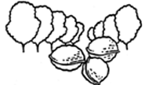

**Volume 41 ▪ October 10, 2012**

Joseph H. Connell

UCCE Farm Advisor

**Guidelines for handling and planting bareroot walnut nursery trees**

*Carolyn DeBuse, UCCE Farm Advisor, Solano and Yolo Counties and Bill Krueger, UCCE Farm Advisor Emeritus, Glenn County*

**Handling bareroot nursery trees**. Walnut bareroot trees may look sturdy but they are very vulnerable to environmental stresses of heat, freezing, and drying out. Though their outward appearance may be unchanged, damage can happen that will decrease their survival or increase possibility of disease. Here are some guide lines that will help ensure their health.

1. Prepare the orchard site before delivery of the trees (see article on site prep in current newsletter). Professional tree cold storage is the best place to store trees once they are dug from the nursery field.
2. Once trees are picked up or delivered, it is very important to keep the roots moist and protect the trees from sunlight, heat and extreme cold. Do not pick up more trees than you can plant in a day.

**

*2279-B Del Oro Ave., Oroville, CA 95965 (530) 538-7201 FAX: (530) 538-7140 Email:* [*cebutte@ucdavis.edu*](mailto:cebutte@ucdavis.edu) *Web Page: cebutte.ucdavis.edu*

University of California, Butte County, and the United States Department of Agriculture Cooperating

To simplify information trade names of products have been used. No endorsement of named products is intended nor is criticism implied of similar products that are not mentioned.

Inquiries regarding the University's nondiscrimination policies may be directed to the Affirmative Action/Staff Personnel Services Director,

University of California, Agriculture and Natural Resources, 1111 Franklin, 6th Floor, Oakland, CA 94607-5200 (510) 987-0096.

Plan to plant the trees as quickly as possible after delivery.

* If trees have been in cold storage, continue the cold storage at your orchard while you’re progressing with planting by renting a refrigeration truck trailer for the trees. Trees must be kept moist even in refrigeration.
* If refrigeration is not possible then store the trees in a cool fully enclosed warehouse keeping the trees moist and covering them with a tarp.

1. Continue the same care of keeping the trees moist and cool while moving the trees to the field and during planting. Take the trees from your onsite storage or refrigeration in very small lots. Move them under tarps or covered trailer keeping them in the shade as much as possible. Keep them moist by spraying them with water while waiting to be planted. If possible move the refrigeration truck to the field and remove trees as needed.

**Planting walnuts.** The most important detail is to manage soil settling so that after a few months

when settling has finished the trees are at the same depth as they were grown in the nursery. A tree planted too deep is more susceptible to Phytophthora crown rot from moist soil against the upper rootstock portion while a tree planted too high can get sunburned roots and dry out too quickly. The following guidelines will help to avoid problems while planting your trees.

* Field soil should be moist but not overly wet for planting.
* Dig the holes just deep enough for the roots. A deeper hole will settle the whole tree lower than desired.
* Augered holes should have the sides roughed up with a shovel to disrupt glazing and prevent roots from circling rather than growing out into the soil.
* Planting on berms or mounds is recommended to allow proper drainage from around the crown of the tree and reduce the chance of disease.
* Trim off broken roots or roots that are too long for the hole. It is best to enlarge the hole to fit the roots than trim them but this is not always possible.
* K-84 bacteria can be used before planting to protect the roots from crown gall. The success of this spray will depend on the type of crown gall bacteria found in the field. It has been shown that it works with some crown gall strains and not others. If used, it is better to spray it on the roots and crown rather than dip trees.
* Use a planting board to ensure that the crown of the tree is in the proper position and slightly above the soil level. This will allow for some settling so the final tree placement is at the proper depth.
* Spread the roots in all directions in the hole. The strongest roots should be placed towards prevailing wind.
* Fill the soil around the roots and pack it down multiple times in the process of filling until the hole is filled. Make sure there are no voids under the root system. The soil should be mounded above soil level to allow for settling.
* Water the tree in with 1-2 gallons of water to help remove air pockets and help settle the soil.
* Head back the trees at 4-5 good buds above the graft or bud union. This will ensure that only a few shoots will start to grow maximizing growth from stored reserves in the tree and decreasing shoot competition.
* Paint the whole tree with a white wash to prevent sun burning. This is critical and should be done the same day as planting. Be sure to paint the crown of the tree all the way down to the soil line. (whitewash: latex interior paint cut with 50% water)
* First irrigation should be applied after the trees have begun to grow.

**Additional planting notes**

* Do not place fertilizer or organic matter in the hole.
* Avoid planting on extremely hot days. Trees dry out too quickly between storage and planting and can be heat damaged if they are not painted and watered in immediately.
* Placing stakes at planting can save the extra step of post pounding and they are ready to go when the trees need staking. For standard spaced orchards, use 10 ft. stakes and place 2 feet below soil level and 8 feet above. Eight foot stakes (2 feet below and 6 feet above) work for hedgerow orchards. Stakes should be placed 12 inches away from the tree on the side perpendicular to prevailing winds with the tree tied loosely to allow for movement and strong trunk development.
* Potted walnuts at this time are sold as unbudded rootstock. The recommended time of planting is in late February or early March. Look for an article in the Spring Walnut News covering this topic more fully. For more information you should contact your local farm advisor.

**Orchard removal and site preparation for walnut planting**

*Joseph Connell, UCCE Farm Advisor, Butte County*

Getting a walnut orchard off to a good start is essential considering the investment cost required to develop a new orchard. It’s a good idea to plan for an 18-24 month transition between existing orchard removal and planting new trees. Trying to rush the operation can create several opportunities for a less satisfactory outcome. Nematode management and soil preparation are two important issues to consider when planning for a new orchard. If you are planting a new orchard in land that has been fallow or in non-host field crops for two or three years, fumigation may not be needed.

**Root Lesion Nematodes.** The root-lesion nematode of concern in California is *Pratylenchus vulnus.* Almost every woody perennial will host this nematode species to varying degrees. English walnut, Paradox hybrid and black walnut rootstock are all highly susceptible with each root tip capable of supporting thousands of nematodes per gram of root. Most *Prunus* rootstocks are a notch lower as hosts but are still considered good hosts of *P. vulnus.* Equally important, *P. vulnus* can flourish in any soil type and at any depth on deep rooted woody perennials. These nematodes will slowly spread across an orchard via tillage and irrigation and can considerably enlarge the area of plant damage.

**Kill existing orchards root systems (and nematodes) before tree removal.** The main value of killing existing roots is to mimic what occurs when you fumigate. Research has shown that glyphosate is best for killing *Prunus* species roots (prunes, almonds, and peaches) while Garlon3A® is best for killing walnuts. Use of Garlon 3A on orchard cut stumps is currently allowed under a Special Local Needs label. Users should have the Garlon 3A label and the SLN for cut stump use in hand when they make the application.

Glyphosate will kill roots as deep as they go while fumigation will kill them down to 4 feet or so. Root killing herbicide application is especially useful in reducing the walnut replant problem whether or not fumigation is planned. Wait at least 60 days after applying the root killing herbicide before removing treated trees or stumps and wait one full year before replanting or you will not get much value from the kill treatment.

There are two methods for killing root systems. The most common method is to cut the tree down and paint the freshly cut stump with herbicide. This method can be used for any orchard crop. The second method is to spray the whole tree before it is cut down allowing the tree to die completely before removing. Whole tree herbicide treatment is only practical for small stature prune and peach trees. If you are removing large almond or walnut trees, use the stump killing method.

**For orchard stump treatments, cut trees with a saw a couple of feet above the ground and paint the cut surface** ***within 5 minutes.***

* **For almonds, prune, and peaches** cut andpaint stump with a straight 50:50 mix of Roundup® (41% glyphosate) and MorAct® before the end of October.
* **For walnuts** cut and paint stump with a straight 50:50 mix of Garlon3A® and MorAct® before the end of October.

Unless the label says otherwise, dabbing a sponge fastened to the end of a broom handle into the liquid, then onto the freshly cut surface has worked well.  An old 5 gallon container with a lip around its top should be filled no more than half full. Avoid getting the bucket handle wet. These mixtures are thick and paint-like and may damage sprayers or their components, and, they are also likely to clog the sprayer. Applicators will need boot covers, eye protection, and other personal protective equipment as labels require. Roundup® and Garlon3A® labels include stump killing recommendations. Be sure to check the labels on the materials you’re using to make sure these relatively simple procedures are in compliance with the label. For more information go to Dr.McKenry’s website <http://www.uckac.edu/nematode/>.

**Fallow period:** It is recommended to not plant directly after tree removal in the same year. Remember that 60 days is required for root killing herbicide to take affect before stump removal. The land should be left fallow or a crop that is not a host to nematodes may be planted the following summer such as Sudan grass or safflower to further reduce nematode populations and create conditions for more effective fall fumigation.

**Plan for effective fumigation if necessary.** Send soil samples to a lab to determine if nematodes are present. Plan to fumigate if lesion nematode (*Pratylenchus vulnus*) is found. Where soil is fallowed, it should be ripped and reworked through the summer to dry the soil to a 5 foot depth. Moisture content at the time of application should be at or below 12-18 percent. Fumigants work better at high soil temperatures so it is important to fumigate before the soil temperatures drop. Complete the fumigation treatment before 2 inches of rainfall occurs after July 1st and before November 15th while soil temperatures are above 55°F at one foot depth.

**Sealing the soil.** Tarping the soil is recommended following a gas fumigant like methyl bromide. Less volatile fumigants can be followed by sealing the soil with tarps or soil compaction and/or water sealing. The more completely the soil is sealed the more thoroughly the fumigant will work killing the soil pathogens and weeds. If fumigant is broadcast, follow the label recommendation of additional water to increase penetration. Follow label recommendation for time needed to aerate the soil before planting.

**Know your soil and your field.** Before planting or replanting, review your local soil survey for information on the type of soils present on your site and their distribution. Soil surveys describe each soil type and provide information about drainage, flooding, exchangeable sodium content and other details important to successful orchard establishment. Using a backhoe to dig pits 5 to 6 feet deep in strategic locations where soil differences are expected will allow for a first hand examination of the soil. Look for stratified soil, compacted zones, hard pans, clay pans, or sand or gravel layers. Abrupt changes in soil density or texture can result in perched water during extremely wet years resulting in unhealthy walnut roots.

Do your best to identify and fix problems before your new orchard is planted. Stratified soils or soils with compacted layers should have these layers disrupted prior to planting. Soil modification in late summer or fall when the soil is dry will ensure the most disruption possible while allowing winter rains to settle the soil before planting. A slip plow, a ripper shank with a steel plate coming from the point of the ripper at a 45 degree angle to the surface, can lift soil at the bottom of the shank to the soil surface and permanently disrupt restrictive layers. Ripping breaks apart compaction or shatters hard pan, while slip plowing mixes soils with a clay pan or other restrictive layers. Both are typically done in two directions, with the second pass diagonal to the first. This subsoil work should be done far enough in advance to allow soil settling to occur before planting. Once settled, low spots should be graded and leveled to improve surface drainage to help keep the future orchard healthy. Planting trees on berms is often recommended to reduce the chance of developing crown rot.

**Diagnosing and managing branch wilt disease**

*Janine Hasey, UCCE Farm Advisor, Sutter/Yuba /Colusa Counties*

The extreme heat waves we experienced this summer may cause problems in walnuts that we often do not see in milder summers. Webspinning spider mites which flare in hot weather were certainly evident in many orchards this year. We usually see more sunburn on nuts of susceptible varieties although many orchards used Surround® or a similar material to prevent damaged nuts. Hot weather also favors the fungal disease Branch Wilt (*Nattrassia mangiferae,* formerly *Hendersonula toruloidea*). Below are the main points you need to know to recognize and manage this walnut disease.

**Symptoms and Damage**

Typically in July and August after a hot spell, the first symptom of branch wilt is yellowing and browning of the outermost branches usually on the southwest exposure of the tree (Photo 1). Next, the leaves suddenly wither and turn brown on the infected larger limbs and remain attached to the twigs even after leaf fall, making diseased trees easy to spot in the fall. The thin outer layer of the walnut bark will peel away, revealing black sooty fungal spores (Photo 2). The fungus kills both the bark and the wood of infected limbs. Look for gray to black discoloration extending to the center of the branch in the shape of a cylinder or partial cylinder (Photo 3). The disease will progress killing large branches if left unchecked for a period of years, eventually even extending into the trunk (Photo 4).

Frequently branches killed by branch wilt are colonized by *Botryosphaeria* species. Sometimes though, *Botryosphaeria* may be misdiagnosedasbranch wiltsince symptoms of smaller branch dieback caused by *Botryosphaeria* resemble those of branch wilt.

For photos of branch dieback caused by *Botryosphaeria* see:

<http://cesutter.ucdavis.edu/Orchard_Crops_254/Botryosphaeria_Blight_-_Phomopsis_Cankers_57/>

**Seasonal Development**

The fungus can only invade bark that is split, frost damaged, or sunburned which is the most common entry point. The black sooty spores that can survive for long periods under hot dry conditions are spread by wind or rain throughout the year; the disease, however, can only develop under warm temperatures growing best at 90oF. The southwest side of the tree is the most likely place to find branch wilt because of a higher frequency of sunburn injury.

**Prevention and Management**

Trees weakened by a disease such as deep bark canker common on Hartley, crown rot, water stress, nutritional deficiencies or low vigor, are more susceptible to sunburn injury and subsequent infection by the branch wilt spores.

* Prevent sunburn injury by maintaining vigorous tree canopies through proper irrigation, fertilization, pruning, and pest control.
* Look for branch wilt symptoms annually right after harvest while there are still healthy leaves on trees.
* Remove diseased limbs cutting back to a lateral branch into healthy wood that shows no discoloration. Pruning does not spread infections so there is no need to sterilize equipment between cuts. Burn all infested wood to prevent further spread.

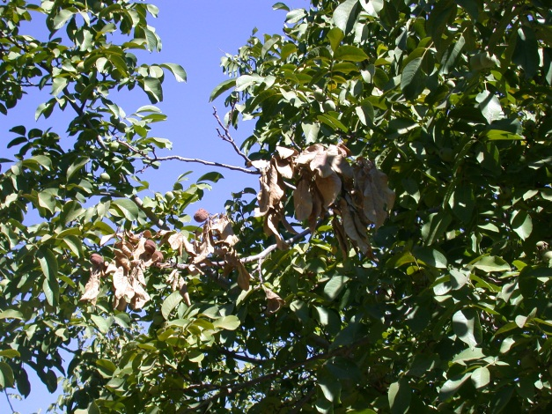

**Photo 1.** The first symptom is sudden leaf browning of the outermost branches. Photo by Janine Hasey.

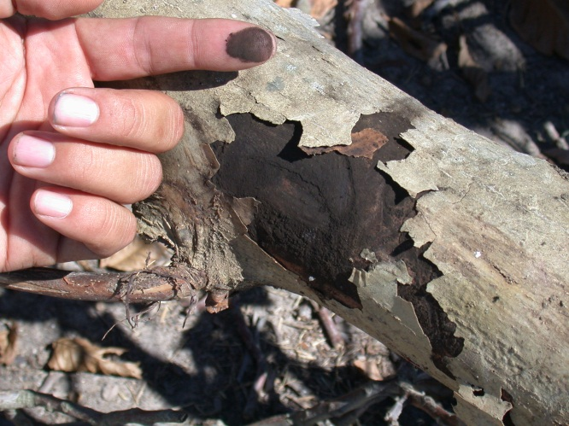

**Photo 2.** Note the outer peeling bark and black sooty spores. Photo by Janine Hasey.

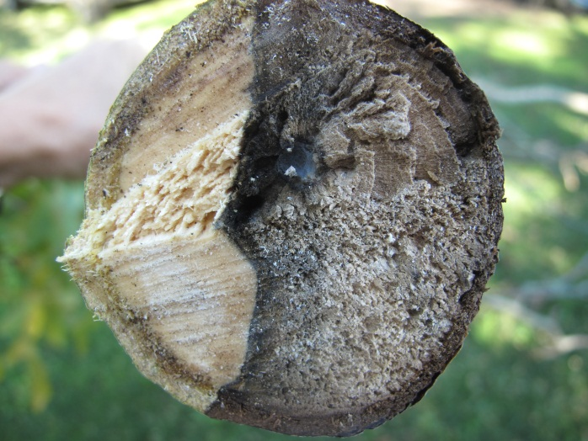

**Photo 3.** Note gray to black discoloration extending to the center of the branch. Photo by Janine Hasey.

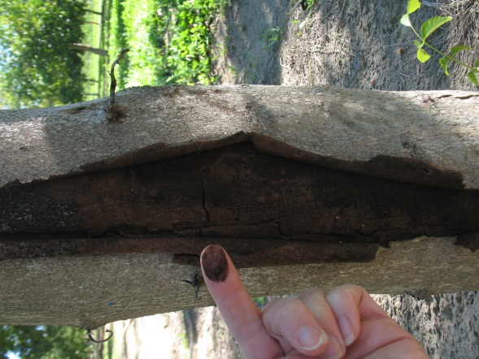

**Photo 4.** Branch wilt can extend intotrunk if left unchecked for several years.Photo by Janine Hasey.

**Management of first year walnut trees in fall and spring**

*Carolyn DeBuse, UC Farm Advisor, Solano and Yolo Counties*

With many young orchards planted this year, I thought it would be a good idea to create a check list for managing first year trees from fall through spring.

**Fall Management**

* No fall fertilization. Last nitrogen should be applied in the first two weeks of August on first year trees.
* Wind damage prevention: in late September, check all staking and tying to prevent blow overs or breakage.
* Freeze damage prevention: trees should be encouraged to set a terminal bud and begin going into dormancy, or “harden off”, to reduce risk of freeze damage from cold snaps early in November. To do this, stop irrigation in September until the terminal bud is set. After the bud is set, you may irrigate in October depending on the weather and autumn rainfall. Do not over stress the trees during this period of hardening off or keep them too wet.
* Make sure that the trees go into the winter with adequate soil moisture. Dry trees are more likely to have damage in cold weather. If rainfall is inadequate into December like last year, winter irrigation may be needed.
* If early freeze/frost damage occurs, white wash the trees so damage does not increase with sun burning in the winter months.

**Spring Management**

* The first pruning or heading should be delayed until late February or early March when risk of freezing temperatures is reduced.
* Head the leader for standard orchard spacing at 8 feet and for hedgerow plantings at 6 feet.
* Remove lower lateral branches that grew the previous season and rootstock suckers while green and small.
* Remove necked buds that are in possible scaffold positions from about 4 to 5 feet up to the top. Remove them by pushing to the side so the secondary bud is not damaged.
* If the leader has not reached the proper height, cut the tree back to 4-5 good buds at the base of the previous season’s growth and regrow the tree as if it was in its first growing season.

Complete articles on these topics can be found at:

<http://cesolano.ucdavis.edu/newsletters/Fruit_and_Nut_Notes39354.pdf> and

<http://cesolano.ucdavis.edu/newsletters/Fruit_and_Nut_Notes39354.pdf>

**Points to consider in the prevention of crown gall**

*Daniel A. Kluepfel; USDA-ARS Crops Pathology and Genetics Research Unit, Dept. of Plant Pathology, Univ. of CA. Davis, Lani Yakabe, Dept. of Plant Pathology, Univ. of CA. Davis, and Janine Hasey, UCCE Farm Advisor, Sutter/Yuba/Colusa Counties*

Crown gall caused by the bacterium *Agrobacterium tumefaciens* can cause significant economic loss in both commercial walnut orchards and nursery operations in California. This results from the fact, Paradox hybrid, the most popular walnut rootstock in California, is extremely susceptible to infection by the crown gall causing bacterium.

Since *A. tumefaciens* is a commonly found soil-borne pathogen we have taken a comprehensive approach in the development of a sustainable crown gall prevention strategy. By comprehensive, we mean we are examining all avenues of *A. tumefaciens* infection from the moment a black walnut seed is picked from the mother tree to the later life stages of a commercial English walnut orchard. We will discuss five areas being examined in our quest to develop a robust comprehensive approach to crown gall prevention. These areas include:

* Pre-plant fumigation/chemical control
* Use of “clean” black walnut seeds in Paradox hybrid rootstock production
* Contamination of graft wood and cutting tools
* Long term soil survival of *A. tumefaciens*
* Identification of novel crown gall resistant rootstocks

**Pre-plant fumigation.** Methyl bromide (MeBr) has been the standard pre-plant soil fumigant for both nursery and commercial walnut production in California. However under the Montreal Protocol, MeBr is being phased out worldwide. To identify effective MeBr alternatives we investigated the direct effect of alternative soil fumigants on *A. tumefaciens* populations in native field soil brought into the laboratory. The MeBr alternatives, Vapam, Telone® C-35, and Telone® C-35 followed by an additional application of chloropicrin, all reduced soil populations of *A. tumefaciens*. However, while 1,3-dichloropropene (Telone® II) applied alone was not effective at controlling *A. tumefaciens*, it is a known reliable treatment for lesion nematode, another major pest of walnuts. The addition of chloropicrin to 1,3-dichloropropene in Telone® C-35 dramatically reduced *A. tumefaciens* populations in soil, but not in buried gall tissue. The additional chloropicrin applied after Telone® C-35 in the “Telone® C-35 plus Chloropicrin” treatment, was needed to reduce *A. tumefaciens* in gall material. Based on our laboratory data, Telone® C-35 is an effective preplant alternative to MeBr for the control of *A. tumefaciens* in soil. In sites with a history of high crown gall incidence, fumigation with Telone® C-35 plus chloropicrin combined with extensive gall removal from the soil should be considered. In conjunction with prior reports on 1,3-dichloropropene (Telone® II) efficacy on lesion nematode, and our laboratory-based data, Telone® C-35 or Telone® C-35 followed by chloropicrin are candidates for consideration in an integrated pest management program controlling the major soil-borne plant pathogens in the California walnut industry. For rates and more specific fumigation information, see “Fumigation Guidelines” in an earlier issue of this newsletter at<http://cesutter.ucdavis.edu/newsletters/Fall_2008_Sacramento_Valley_Walnut_News36490.pdf>

**Long term Agrobacterium survival.** Once *Agrobacterium tumefaciens* is introduced into a field site it has the ability to survive for years in the soil in the absence of any plant host. For example, we documented *A. tumefaciens* survival for at least 2 years in orchard soil and at least 1.5 years in non-irrigated fallow soil. In addition, the *A. tumefaciens* strain we introduced in the orchard soil, and reisolated 2 years later, retained the ability to induce crown gall formation. Given these data, a fallow rotation does not appear to be an effective approach to reduce *A. tumefaciens* populations and limit crown gall formation.

**Importance of using “clean” black walnut seeds for Paradox hybrid rootstock production.** Soil fumigation dramatically alters the composition of the microbial community in soil. The end result is a community which often is compromised in its ability to limit or inhibit soil-borne pathogenic microorganisms which enter fumigated field sites. Consequently, it is imperative that only “clean” (i.e., free of plant pathogens) planting material be used in these situations.

Recently we explored avenues for *A. tumefaciens* to enter the rootstock production system and cause crown gall. We found if black walnut seeds were shaken to the orchard floor, where they could sit for up to 48 hours, we were able to detect *A. tumefaciens* on the seeds. Interestingly, we found the longer the seeds remained on the orchard floor prior to harvest, the greater the percentage of *A. tumefaciens* contaminated seeds were discovered. Even though this represents a previously undiscovered way in which *A. tumefaciens* can enter the rootstock production system, it should not have come as much of a surprise to us since, as mentioned above, *A. tumefaciens* is an excellent survivor in soil.

We now hypothesize the following avenue as being important in crown gall incidence. Black walnut seeds are shaken to the orchard floor where they may lay for 6 to 24 hours. During this time, the seeds become contaminated with soil which may harbor the crown gall pathogen. These *A. tumefaciens* contaminated seeds are then planted in freshly fumigated soil which contains a compromised native microbial community unable to suppress populations of *A. tumefaciens* which are hitching a ride on contaminated seeds. This results in establishment of the crown gall pathogen in soil where it is ready to infect the walnut seedling upon emergence from the germinating seed. Given this scenario, we propose a cost effective way to reduce crown gall incidence is to limit or eliminate contact of the black walnut seed with the ground prior to planting in fumigated soil. This could be accomplished using a catching frame or even shaking the mother trees on tarps spread on the ground prior to shaking. Regardless of the method, the key point remains, eliminate soil contact by the black walnut seeds prior to planting in fumigated soil and you will, most likely, decrease crown gall incidence on susceptible walnut rootstocks.

**Contaminated grafting tools and graft wood.** The importance of grafting tool sanitation has been demonstrated for numerous crops in which plant pathogens, including *Agrobacterium*, are readily transferred from plant to plant via grafting tools. We recently demonstrated the importance of grafting tool sanitation in crown gall prevention during production of grafted walnut trees on Paradox seedling rootstock. When sanitation measures are not followed, Paradox seedlings can develop galls at the graft union or bleeding wounds. This implicated not only the involvement of improperly sanitized grafting and cutting tools but also potential *Agrobacterium* contamination of graft wood. Grafting tools and graft wood should never be left on soil where they can become contaminated with *A. tumefaciens.*

Bleach, a standard sanitizing agent is an effective disinfectant of water and solid surfaces. However, it is corrosive and rapidly inactivated by dissolved or suspended solids such as organic matter, which are common in field situations. Surfactants/detergents are potentially effective alternatives for the control of microorganisms in environments with high levels of organic matter. We have shown that surfactants known as quaternary ammonium compounds, effectively reduced populations of *A. tumefaciens* in solutions and on solid surfaces. The detergents, benzalkonium chloride (BC), Cetyl trimethylammonium bromide, (CTAB) and Physan 20 rapidly reduced populations of *A. tumefaciens*. More importantly, BC and CTAB activity was only reduced by 16% in the presence of organic material which reduced bleach efficacy by 64%. In our laboratory trials these detergents dramatically reduced bacterial contamination on cutting blade surfaces which lowered gall formation in grafted test plants and were less phytotoxic than bleach. We are now exploring potential use of these materials in the field.

On a bit of a side note, it is important to remember, crown galls can harbor large populations of the crown gall pathogen *A. tumefaciens*. Therefore, when conducting any type of gall removal operation, it is important to disinfect cutting tools after use on gall tissue and properly dispose all gall material after removal (i.e. remove from orchard and burn). Finally, before using disinfectants or other pesticides, be certain they are registered for that use in California.

**Host Resistance.** The best form of disease control is the identification and development of disease resistant hosts. Our walnut rootstock improvement team has made significant advancements in the identification of walnut genotypes which exhibit resistance/tolerance to key soil-borne pathogens including *Phytophthora*, *Armillaria* (oak root fungus), lesion nematodes and *A. tumefaciens* (crown gall). In particular, Texas black walnuts *(Juglans microcarpa*) have been found to exhibit elevated resistance to several of these key pathogens. By crossing Texas black walnuts with English walnuts (*J. regia*) we generated a hybrid that continues to exhibit tolerance to crown gall. These new hybrids will now be examined under various field conditions. The clonal Paradox rootstock ‘Vlach’ also has shown some resistance to crown gall in the field and in screening trials. However, these observations need further validation.

**Overall Prevention Strategy.** Since the crown gall pathogen is a common soil-borne bacterium, we need to maintain a comprehensive approach in our disease prevention strategies for crown gall. Based on our laboratory-based research and field observations, we developed a series of suggestions we feel will aid in the battle against crown gall. These include:

* Eliminate exposure of walnut seeds and graft wood to field soil prior to planting or grafting/budding
* Surface sterilize grafting tools frequently
* Limit time between nursery or cold storage pick up and planting and keep nursery planting stock cool prior to planting
* Fumigate planting sites with Telone® C-35 or Telone® C-35 followed by Chloropicrin in heavily infested crown gall sites.
* Limit wounding of plant material
* Avoid planting too deep
* Avoid mounding soil up on newly planted trees
* Keep crown of tree as dry as possible; *Agrobacterium* is favored by wet environments