GUIDELINES FOR FOOD PREPARATION AND FOOD PRESERVATION

- Select a favorite recipe from any source.
- The recipe does not have to be a recipe in your project book, but it must enter into one of these categories:
Beef Poultry Pork Fish/Game/Lamb/other
Pasta/Bread Rice/Bean/Vegetable Cookies/Candy Cakes/Pies
- The recipe should not be prepared exclusively from commercial mixes.
- Food Preservation members prepare a dish using a product you have preserved. Use canned fruits, jams, jelly, etc. within a recipe, not alone.

- Plan a nutritionally balanced menu including items from the My Plate in which your favorite food recipe will be used. The menu must be a breakfast, lunch, dinner, or special occasion meal. Be prepared to answer the judges if they ask about your menu.

- Plan the table service needed to attractively serve the food. Include dishes, flatware, tablecloth or mat, napkins, glasses, centerpiece or other items appropriate to your menu. Be sure to include a serving fork or spoon. Remember your display must be no larger than 3ft by 3ft! Fine china and silver are not a criteria. In fact, you bring them at your own risk. Plan to use what you have at home. Bring only one place setting. Remember, the container you prepare and serve your food in should be appropriate for your menu.

- Prepare your favorite food recipe AT HOME. The committee for Food Fiesta would like to remind all the participants that while preparing your food please remember these guidelines:
- Wash your hands before handling and preparing food.
- Refrigerate any food that needs to be.
- Cook thoroughly any type of meat used in your recipe.
Refrigeration and holding oven space will be provided for your entry at the school until time of judging.

- You may list your complete recipe on the front side and a balanced-meal menu on the back side of a single sheet or on two separate sheets of paper, tent cards work as well.

- At Foods Fiesta, set up your display and include on the table the following items:
- The prepared favorite food item in an appropriate serving dish, with serving utensil.
- A place setting for one person, appropriate to your menu and THEME (optional).
- Card with menu and recipe. (Displayed)

- Your 4-H Foods Fiesta exhibit will only count as a presentation toward the fair requirement if you follow the standard 4-H presentation format and have a score of 35 or above. If below 35 points this does NOT qualify for your fair presentation requirement. ONLY Presentations given according to the State Presentation Handbook will count as a Presentation in your record book.
Remember to use the standard 4-H presentation format AND PRACTICE!
My name is:______________________________.
I am from the _________________________ 4-H club.
This is my ______________ year in 4-H.
Today I have prepared _________________________.

- Serve the judges your “favorite food” when they arrive at your table. Disposable gloves will be provided and must be used when serving.
SAMPLE TABLE SETTING
Guide for Table Setting

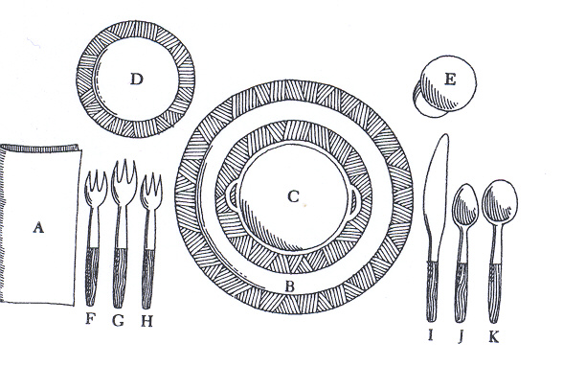 (basic setting)
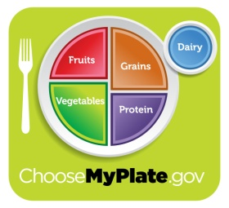

INFORMAL DINNER

A. Napkin; B. Dinner or service plate: C. First course bowl and liner plate; D. Salad plate; E. Water goblet; F. Salad fork; G. Dinner fork; H. Dessert fork; L. Dinner knife; J. Teaspoon; K. Soup spoon.
University of California
Cooperative Extension

