

California 4-H

Record Book Manual

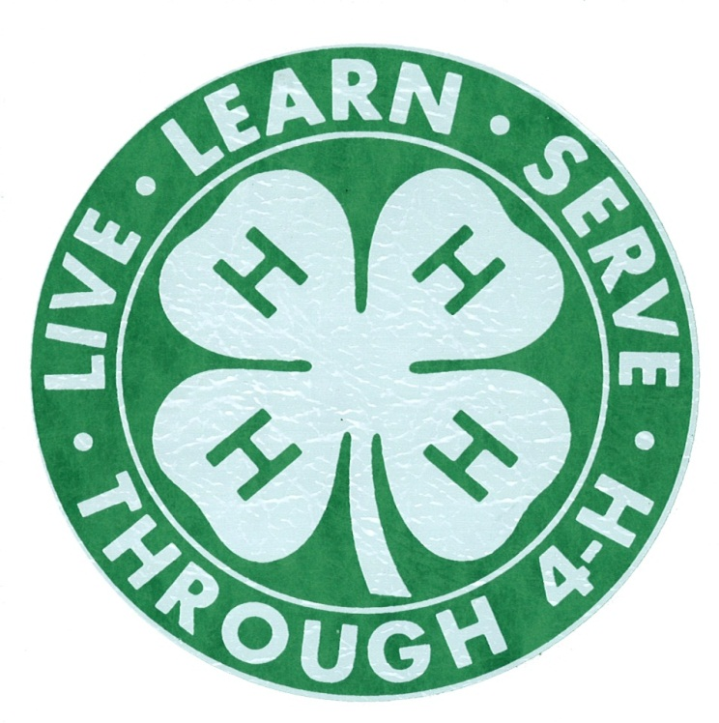

2011-2013

Compilation of the 2011 Record Book Manual and the 2012 Addendum

This manual supersedes all others

Typeface in blue indicates 2012-13 modifications

Table of Contents

Purpose Page 3

4-H Online Record Book Page 4

4-H Record Books and Positive Youth Development Page 5

Evaluation and Competition Page 8

Process Instructions Page 9

Formatting Instructions Page 12

Organization Overview Page 14

Section 1: Preliminary Information Page 15

Section 2: Personal Development Report (PDR) Page 16

Section 3: My 4-H Story Page 28

Section 4-A: Annual Project Report (APR) Page 29

Section 4-B: Junior/Teen Leadership Development Report (JTLDR) Page 32

Section 5: Collection of 4-H Work Page 38

Section 6: Previous Years’ Records Page 39

California State 4-H Office One Shields Avenue Davis, CA 95616-8575 530-754-8518
fourhstateofc@ucdavis.edu

Copyright © 2013 The Regents of the University of California.

The University of California ) Division of Agriculture & Natural Resources (ANR) prohibits discrimination against or harassment of any person participating in any of ANR’s programs or activities on the basis of race, color, national origin, religion, sex, gender identity, pregnancy (which includes pregnancy, childbirth, and medical conditions related to pregnancy or childbirth), physical or mental disability, medical condition (cancer-related or genetic characteristics), genetic information (including family medical history), ancestry, marital status, age, sexual orientation, citizenship, or service in the uniformed services (as defined by the Uniformed Services Employment and Reemployment Rights Act of 1994: service in the uniformed services includes membership, application for membership, performance of service, application for service, or obligation for service in the uniformed services) or any person in any of its programs or activities.

University policy also prohibits retaliation against any employee or person participating in any of ANR’s programs or activities for bringing a complaint of discrimination or harassment pursuant to this policy. This policy is intended to be consistent with the provisions of applicable State and Federal laws.

Inquiries regarding the University’s equal employment opportunity policies may be directed to Linda Marie Manton, Affirmative Action Contact, University of California, Davis, Agriculture and Natural Resources, One Shields Avenue, Davis, CA 95616, (530) 752-0495.
Purpose of Record Books
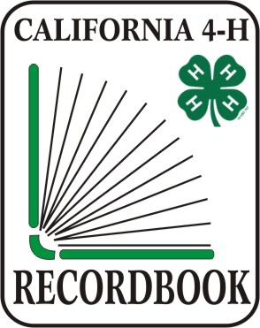
History
The California 4-H Youth Development Program (YDP) has a long history of record-keeping as an activity by 4-H members. In early 4-H history, Record Books focused on project profit and loss and other activities in agricultural and home economics projects. As 4-H moved from a primarily agricultural focus to encompassing suburban and urban clubs, the Record Book process changed. In the 1980’s, the Record Book was reformatted to conform to national achievement (which was then eliminated in the early 1990’s) and the core values of the 4-H YDP. In the 21st century, the 4-H Record Book has undergone another transformation to ensure positive outcomes of youth participating in the 4-H YDP. Practices have been modified to meet the needs of a changing society. In order for the 4-H Record Book process to move youth on a path toward thriving within their communities, it has undergone changes to meet the mission of 4-H YDP.

The Purpose of Record Book:

4-H Record Books serve a variety of purposes in the California 4-H Youth Development Program.

- 4-H Record Books give members an opportunity to reflect on their yearly work. They document their skill development and their learning experiences in a written report. 4-H members measure their achievements and growth in their total years in 4-H.

- 4-H Record Books encourage members to set goals, pursue strategies to meet those goals, and to shift gears in the face of challenges and obstacles. Completion of the Personal Development Report awards 4-H members for participation in 4-H activities, which provides an incentive for participation, learning, and achievement.

- Completing a 4-H Record Book is a process where 4-H members record project and club work. Records management is a competency skill to identify, create, classify, archive, and preserve records. The 4-H Record Book teaches 4-H members these skills through a standard format.

- Record Books promote positive youth development. Youth development is the process through which youth acquire the cognitive, social, and emotional skills and abilities required to navigate life. This development occurs throughout a young person's life. Continued exposure to positive experiences, settings and people, as well as opportunities to gain and refine life skills, supports young people in the development of the 6 Cs: competence, confidence, character, caring, connection, and contribution.

4-H Online Record Book

http://www.ca4h.org/4hbook/

The 4-H Record Book has undergone transformations over the years to ensure that it meets the needs of our 4-H members. In September 2011, the 4-H Online Record Book was unveiled. This transformation re-engages young people through a fun, interactive format that offers social networking opportunities for members and volunteers within clubs.

The 4-H Online Record Book (ORB) is the Record Book of choice. The State 4-H Incentives and Recognition Advisory Committee encourages youth and adult volunteers to transition to the use of the ORB.

The 4-H Online Record Book:
- Has a social connection! It extends opportunities to stay connected to other club members and leaders online.
- Is a fun and interactive way to log 4-H activities and events.
- Is a more efficient way to keep Record Book information. No more worries about lost pages or misplaced work.

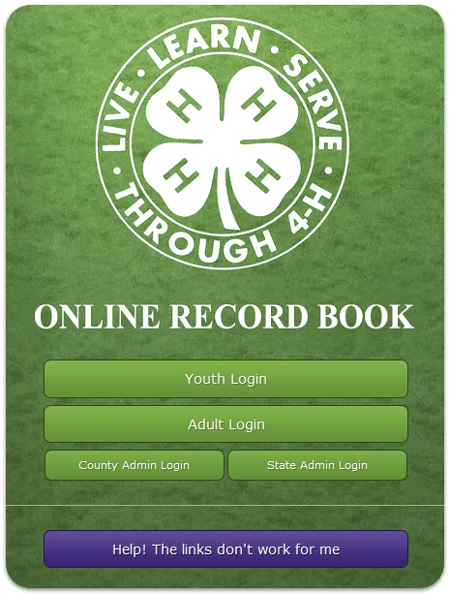

4-H Record Books and

Positive Youth Development

Thriving in Youth Development
Thriving is a relatively new construct within the field of Positive Youth Development. Until recently, there was little research about thriving, and consequently, the concepts have often been unrecognized, misunderstood or disconnected from on-the-ground practice. Recently, a number of researchers have made significant investments in order to understand the key indicators for thriving, and to ascertain the positive roles of family, school, and community organizations toward growing thriving youth.

In partnership with The Thrive Foundation for Youth, 4-H is actively translating current research in to practical applications through the development of thriving educational materials, volunteer development strategies, and data collection. All of these components are reflected in the 4-H Record Book. 4-H Record Books support this model by helping members to:
- Identify and nurture their spark(s). Sparks are passions and skills that are meaningful and motivating. It's what unleashes your energy and joy, gives your life a purpose and focus, and allows you to make a unique contribution to the world.
- Develop and practice a growth mindset. The effort that members put into completing the Record Book helps strengthen the connections in their brains. A growth mindset includes viewing challenges as opportunities to learn even if it means changing a goal or strategy.
- Practice GPS goal management skills. Throughout the 4-H Record Book, members set Goals, Pursue strategies to reach those goals and Shift gears in the face of challenges or obstacles.
- Practice self-reflection skills on indicators of thriving. Members who demonstrate growth in the 6 Cs: competence, confidence, character, caring, connection, and contribution, are on the path to thriving. The 4-H Record Book encourages members to set goals related to the 6 Cs and to reflect on their growth toward thriving.

Essential Elements of Youth Development

Research shows that focusing programs on the four essential elements of youth development creates healthy and happy young people, who demonstrate a sense of maturity and civic engagement as adults and become stronger individuals, creating stronger families and better communities. These essential elements include belonging (caring relationships), mastery (constructive learning experiences), independence (leadership opportunities), and generosity (service to communities). 4-H Record Books support each of these by:
- Belonging: 4-H members are awarded for their participation in activities, earning symbols of belonging as they continue in 4-H (e.g., stars, achievement pins, etc.).
- Mastery: Through competition, 4-H members receive feedback on their participation and record keeping skills so they can improve and grow.
- Independence: 4-H members are encouraged to participate in leadership development activities (e.g., Junior and Teen Leader, officers, committee chairs, etc.).
- Generosity: 4-H members are provided an incentive to engage in their communities through positive citizenship and community development activities.

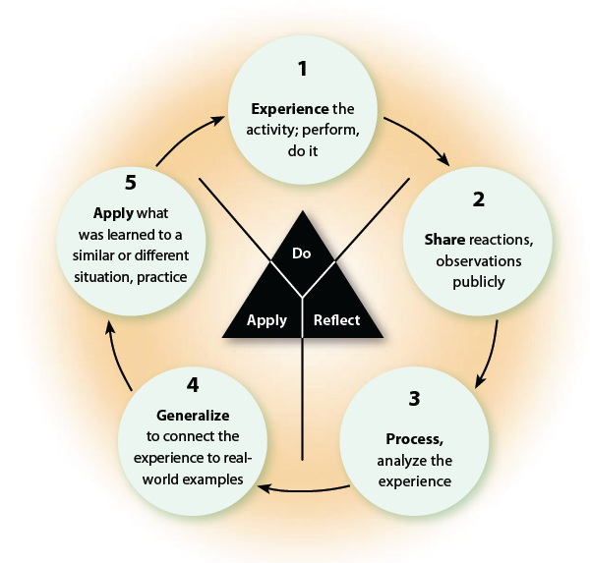Experiential Learning Cycle

4-H utilizes a learn-by-doing model called Experiential Learning which engages youth in hands-on activities. 4-H Record Books can play an important role in this process during the reflection stage. 4-H members share and process their experience by recording what they did and learned at each project meeting on the Annual Project Report. This report helps the 4-H member summarize their activities and learning experiences in their projects.

Learning Strategies
4-H members differ on learning strategies that best shape their ideal learning experience. 4-H volunteer and members must make selections that consider age, developmental stages, and the needs of the group to ensure a positive and enjoyable learning experience.
- Competitive Learning – Competitive learning encourages high levels of individual achievement, but also creates many more losers than winners. This can be harmful to youth.
- Individualistic Learning – Individualistic learning encourages independence but does not provide participants with any information about their peers. It requires development of standards for youth to work towards. 4-H Record Book competitions may focus on either or both of these types of learning strategies.
- Cooperative Learning – Cooperative learning encourages the development of social interaction skills. Group members learn and experience interacting directly with one another. Completing 4-H Record Book forms can be done in a cooperative learning environment. Combined with the experiential learning cycle, group members can reflect on their project work as a group to gain valuable insight from one another.

Age-Appropriate Development
The 4-H YDP is based on the needs and interests of its members. 4-H Record Books must be developmentally appropriate for participants and appropriate for the delivery mode. Expectations of 4-H Record Book completion and standards change as 4-H members become older, more experienced, and are thriving in 4-H, school, and in their community.

- Primary members do not complete a 4-H Record Book. Some counties have simple forms specifically designed for 5-to-8 year olds. Primary members are not eligible for 4-H Record Book awards or competition. Primary work is not carried over to the PDR when he/she becomes a regular member.

- Junior (9 – 10 years old)
- Participation should be limited to cooperative learning activities with limited competition.
- Junior members should have frequent meetings with work divided into time-limited units. Meetings and group activities are important. Project lessons should be short.
- Junior members should learn about what makes up a community. Learning experiences should involve structured exposure to community work environments.
Ideas for 4-H Record Books:
- Have 4-H members work together on their Annual Project Report, Expression Pages, or My 4-H Story.
- Place a higher emphasis on completing the forms but not on specific formatting guidelines. Do not encourage 4-H Record Book competitions.

- Intermediate (11 – 13 years old)
- Participation should include cooperative learning and individual work with limited competition as an evaluation tool.
- Intermediate members should be encouraged to take an active role in decision-making at the unit level, i.e., committees, officers, and activity planning.
- Intermediate members should be encouraged to assist the younger members. Tasks may be to notify members of meetings, assist the project volunteers with setup or clean up, taking attendance, or demonstrating skills.
- Advanced projects should be offered to those who are interested. Talks, discussions, tours, conferences, and group educational activities are appropriate.
Ideas for 4-H Record Books:
- Have 4-H members show younger members how to complete a 4-H Record Book.
- Allow for creativity on 4-H Record Book forms.
- Encourage 4-H members to focus on providing in-depth information on one or two projects, but perhaps not on all of their projects.

- Senior (14 years old and above)
- Participation should include individual and team work, with limited competition.
- Senior members should be encouraged to take an active role in decision making by providing leadership, such as leading projects and serving as committee chairs or officers. They should participate in implementing and evaluating activities.
- Senior members should be encouraged to identify individual goals, acquire the resources, and do the research to pursue specific interests.
- Senior members should be encouraged to be role models for younger members and provide leadership at the unit, county and section levels. Responsibilities may include teaching, program management, event planning and/or program promotion.
- Senior member involvement should expand beyond the local unit level to county functions, community service and involvement with others.
Ideas for 4-H Record Books:
- Encourage 4-H members to demonstrate their growth in the My 4-H Story, Expression Pages, Collection of 4-H Work and Previous Years’ Materials.
- Ask 4-H members to provide detail on what they did and learned on the Annual Project Report and/or Junior and Teen Leadership Development Report.
Evaluation and Competition

4-H Record Book competitions measure members’ leadership development, citizenship activities and personal growth, as well as project proficiency. 4-H Record Books may be judged at the club, county and state levels.

The Purpose of Record Book Competitions:
- Provides an incentive to members to record their project work and personal achievement in their 4-H Record Book.
- Members receive feedback and encouragement on their 4-H project skill development, leadership and citizenship development and record-keeping skills.
- Members are recognized for outstanding 4-H work.

Club Review
4-H Record Books are first reviewed at the local level by 4-H Community Club/Unit Leaders and Project Leaders. Club level review is based on the Danish system where 4-H Record Books are reviewed against a standard. Seals are awarded based on the member’s 4-H project work, personal growth and the book’s organization. Through their personal achievements and 4-H participation, members may earn Star Rank recognition.

County Competition
Members may submit their 4-H Record Books for county competition. County Record Book requirements should mirror those required by state competition. Books are judged on the member’s 4-H work, leadership and citizenship development and personal growth. County level judging should be based on the Danish system with all books judged against a standard. Judges provide a critique and suggestions for future growth and involvement. Counties may designate awards for 4-H Record Books based on meeting published standards.

State Judging

Senior 4-H members are eligible to enter state competition. State level competition is focused on recognizing 4-H members who have outstanding 4-H Record Books. Forms, additional instructions and specific age eligibility may be found at http://www.ca4h.org/Resources/Members/RecordBook/RBCompetition/

Please Note: Modifications made to the forms, formatting or requirements outlined in this manual or omissions by the member, club or county are reasons for disqualification. Counties are encouraged to follow the same guidelines for county judging as specified for state competition so that youth are following the same guidelines for all levels of competition. Formatting differences due to the export of form from the Online Record Book are acceptable.

The 4-H Online Record Book (ORB) is the Record Book of choice. All ORB default print features are acceptable for all levels of competition. Please note that exported forms from the Online Record Book may not conform exactly to specifications listed in this manual or listed in county requirements. Club and county level competitions may not disqualify or exclude a book from competition on the basis that the book was created in 4-H ORB.
Process Instructions

Not Required for 4-H Membership
4-H Record Books are a valuable and educational component of the 4-H YDP. 4-H Record Books are not required for membership or for participation in 4-H activities such as club events and activities, or for attending 4-H camps or conferences. The 4-H Record Book process must be based on educational criteria and approved by 4-H staff. Notification of 4-H Record Books requirements must be given to the member at the time of enrollment. A 4-H Record Book may be required to receive participation awards (such as star ranking, medals or pins based on 4-H Record Book achievements). See the 4-H Policy Manual at http://ucanr.org/sites/UC4-H/Administration/Policies/Chapter13/#VIII

Online Certification Requirement for State Competition

Members who plan to submit a 4-H Record Book to State Competition MUST complete the Quick Start RB Course by October 1st of the year of competition. This course is approximately 20 minutes long and must be completed annually. The Quick Start RB Course will be available as an online course. It will launch on the 4-H State website by May 1, 2013 and will remain active year-round after that.

Others who may find the course helpful in their work include:
- UCCE 4-H Staff
- 4-H Community Club Leaders
- Volunteers working with county Record Book competition

Verification of the Completion of 4-H Work

Proper signatures are required to confirm the completion of 4-H work. The 4-H Community Club Leader and Project Leaders approve and verify 4-H work undertaken by the 4-H member. Approval, either a digital signature in the Online Record Book or ink signature are required on the following forms:
- The first page/cover of the Personal Development Report: 4-H member, parent and 4-H Community Club/Unit Leader
- The last page of each Annual Project Report: 4-H member and project leader
- The pre-project and post-project part of each Junior and Teen Leadership Development Report: 4-H member and project leader.

Timeline
Counties set their own 4-H Record Book deadline dates. A 4-H Record Book may only contain information and records from the previous 4-H program year (twelve-month period).

Adult Participation
4-H Record Books must be completed by the 4-H member. This includes completing forms, writing the My 4-H Story and other records. Adults may assist by guiding, explaining, helping to compile information and proofreading.

4-H Enrollment
PDR member participation and star rankings transfer from one California County to other counties. Former participation in other states can be counted in the California 4-H Record Book Personal Development Form with documentation of activities.

Hours of Participation
4-H members are asked to record the number of hours spent in 4-H meetings, activities, events, planning/organizing and other 4-H activities in the Personal Development Report and Annual Project Report form. Time should be recorded as decimal or whole numbers. For example, if an activity was one hour and 30 minutes, it would be recorded as 1.50 hours. See the time conversion chart link below to help partial hours to decimals. Do not count hours the member is not spending in a 4-H activity (for example, do not count hours the member is asleep at 4-H camp). While hours are not used to calculate star ranks or other incentive awards, they provide information about the amount of time youth contribute to their own development and to improving the community.

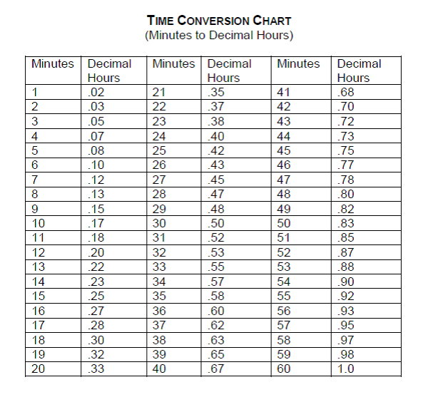

Special Accommodations
The core values of the California 4-H Youth Development Program state that we “appreciate, respect and value diversity through a commitment to inclusion of diverse Californians.” Accommodations must be made for 4-H members who cannot complete the 4-H Record Book in the usual format. A note detailing the accommodation must be included with the 4-H Record Book. Examples of accommodations may include:
- Having a 4-H member verbally provide the information while a project leader or parent transcribes.
- Having a project leader or parent assist with assembling materials.
- Other accommodations may be arranged with the advice and approval of the 4-H Community Club/Unit Leader and/or County 4-H Office.

Questions?
Questions may arise as 4-H members are completing a 4-H Record Book. These questions may regard guidelines for formatting and organization, counting activities on the Personal Development Report and other related areas of the book. The 4-H Record Book is interpreted by using this manual and completing the Quick Start RB Course.

The State 4-H Office and Statewide 4-H Incentives & Recognition Advisory Committee is responsible for developing the forms and instructions for the 4-H Record Book and instructing county 4-H staff and county I & R committee members on their use.

“Children are one third of our population and all of our future.”
~Select Panel for the Promotion of Child Health, 1981
Formatting Instructions

The format of 4-H Record Books will depend on whether the 4-H member uses the Online Record Book or paper forms, the 4-H member’s age, experiences and whether he or she is entering the book for competition. While following formatting guidelines is important, the benefits of completing a 4-H Record Book are a positive and important experience.

4-H members completing paper 4-H Record Books at the project and club level may either handwrite or use a computer to record information. 4-H members may handwrite their 4-H story or type it on a computer.

Formatting a 4-H Record Book

These formatting guidelines help judges review 4-H Record Books entered for competition. 4-H Record Books must follow these formatting guidelines, unless otherwise stated, when entered into a 4-H Record Book competition.

The 4-H Online Record Book (ORB) is the Record Book of choice. All ORB default print features are acceptable. Please note that exported forms from the Online Record Book may not conform exactly to these specifications and are still acceptable.

- Paper: Use 8 ½” x 11” plain white regular paper for all sections. Pages may be double-sided, except for the My 4-H Story which must be single-sided. For pages with photographs in the Collection of Work and/or Expression Pages, photo quality paper is acceptable on those pages only.

- Margins: Use a minimum of 1 inch margins on all sides, all pages. (If used, headers, footers and page numbers may be outside of these margins.

- Typeface: Books must be handwritten or typed in black ink. If handwritten, text must be written legibly. If typed, font size must be at least 11 point in an easy to read font (e.g. Garamond, Arial, Times New Roman, or Helvetica). Font size may differ for headings and emphasis in text.

- Spacing: Text may be single or double spaced (4-H member’s preference).

- Do not exceed page limitations as specified for each section.

- Do not use plastic page covers or laminate any pages.

- Folder or Binder: Use an Acco fastener folder or 3-ring binder, not more than 1” wide.

- Tabs and Divider Pages: Tabs and divider pages help separate sections and improve overall organization. Paper color other than white may be used.

- Graphics: Graphics, pictures, and drawings may be included on the title page, table of contents, Expression page(s), and Collection of 4-H Work. Do not use graphics, pictures, or drawings in any other sections or forms.

- Page Numbers: Use a logical system to number the pages of the Record Book. Hand numbering is acceptable due to the significant number of inserted pages. Numbering using printed stickers is acceptable.

ORB Inserting Pages Overview
When a member prints out the Record Book from ORB, he/she will still need to assemble the book in the proper order as specified in the Record Book Manual. It will be necessary to create the following pages and either:
1) upload them into ORB as photographs in a .jpg or .pdf format and insert after printing where appropriate or
2) print out separately and insert where appropriate.

Option one (1) is recommended because then all of the Record Book documents are archived in the members Online Record Book.

The documents that need to be created outside of the ORB are:
Title Page
Table of Contents
Collection of 4-H Work
Expression Pages
Previous Years’ Records
Organization Overview

A California 4-H Record Book contains the following items:

Section 1: Preliminary Information
- Title page
- Table of Contents

See section 1 instructions for more information.

Section 2: Personal Development Report

4-H members record activities that they have completed during the year. 4-H members may earn stars based on their participation in 4-H over a number of years. See section 2 instructions for more information.

Section 3: My 4-H Story

Reflection on 4-H work completed. 4-H members have an opportunity to reflect on their achievements, knowledge gained, learning experiences, and project work. See section 3 instructions for more information.

Section 4: Projects

4-H members document their specific project work including meetings attended, profit/loss in their project, and knowledge and skills gained. Place items in the following order for each project:
- Section 4-A: One project report form for every project the member has completed.
- Section 4-A: One expression page for every project.
- Section 4-B: Junior and Teen Leadership Development Report.
Each project should have all materials grouped together (for example, all of the rocketry project forms should be together; all of the woodworking forms together, etc.).
See section 4 instructions for more information.

Section 5: Collection of 4-H Work

These materials support the previous sections in showing growth and experience in 4-H. They may include the following: newspaper clippings, 4-H flyers or brochures, 4-H letters, 4-H photographs. See Section 5 instructions for more information.

Section 6: Previous Years’ Records

4-H members include a summary of their previous years’ records at the back of the book.

Section 1: Preliminary Information

Title Page

A title page introduces the 4-H Record Book at the front of the 4-H Record Book. The page includes the member’s name, 4-H Club, county, and the program year. The title page may be a color other than white paper, use graphics, photos, and larger text. The title page must not exceed one standard page.

Table of Contents

A table of contents lists the order of the 4-H Record Book sections. Include the titles of the section headers and page numbers. A 4-H Record Book is organized into the following sections.
- Section 2: Personal Development Report
- Section 3: My 4-H Story
- Section 4: Projects. This section includes Annual Project Reports, Expression Pages, and Junior and Teen Leadership Development Reports. Each project may have its own subsection or all of the projects may be contained within one section.
- Section 5: Collection of 4-H Work
- Section 6: Previous Year’s Records

“Strive for excellence, not perfection.” ~ H. Jackson Brown Jr.

Section 2: Personal Development Report (PDR) Instructions

4-H members record their participation and activities in 4-H and outside of 4-H for the current 4-H program year on the Personal Development Report. Items cannot be counted in multiple categories (known as “double-counting”). However, if a member participates in multiple activities during one event, those separate activities may be counted and attendance at the event may be counted.

Additional Space
The 4-H member may add or delete additional pages or lines for each category, as needed.

Level of Participation
In categories 2 thru 8, the member must identify the level at which the activity took place.
- I = Individual: independent, individual activity, not as part of a group
- L = Local club, unit, project, club/project committee
- C = County, area/district, multi-club
- M = Multi-county, section, or region
- S = State
- N = National, multi-state
- G = Global, international, crossing U.S. boundaries

Star Achievement Ranks
Star Ranks are designed to encourage members to participate in a wide variety of activities over a number of years. Stars provide 4-H members opportunities to accomplish goals. Each star level takes an average of two years to complete.

Inside versus Outside of 4-H Activities
Up to two significant activities outside of 4-H are allowed in categories 2 and 4 through 7, while other activities outside of 4-H may be counted in category 8. To record activities in categories 2 and 4 through 7, they must meet the instructions and guidelines for the category.

Items from Last Year
Occasionally, a 4-H member may forget to record an activity on his/her Personal Development Report. The 4-H member may count an item from the last program year in the current year’s PDR if they have sufficient proof of its validity (e.g. record of their attendance, etc.) and approval of the
4-H Community Club Leader. In the current PDR, the 4-H member should list the year/date, the activity and a short explanation for the past year date. Activities from prior years other than the last year cannot be recorded in the PDR. In ORB, you may go back to a previous year’s record and add the activity in the appropriate year.

1. 4-H Projects Completed*

* Required for a Star Rank
- Purpose: This category records projects a 4-H member has completed.
- Only 4-H projects with a completed and signed Annual Project Report may be counted. To receive credit, the project report must be included in the 4-H Record Book.
- A minimum of six hours of project instruction is required to complete a project.
- During the current year, 80% average attendance across all projects is required to receive an achievement rank.

2. 4-H Project Skill Activities
- Purpose: This category records activities where 4-H members either exhibited their 4-H project work or demonstrated their knowledge to an audience and/or judge.
- Exhibits – Report 4-H shows or events and their location where the 4-H member exhibited 4-H work from a 4-H project (such as livestock, clothing, food, pictures, artwork, or other project items). 4-H members may receive credit for the same exhibit presented before new audiences at different events.
  - Judged Exhibit – Each separate project judged counts as a credit. Multiple items from one project count as one credit. Projects are defined to be those in which a separate Annual Project Report would be completed. Showmanship: A credit is received for each project exhibited. Multiple entries from one project count as one credit. Projects are defined as those in which a separate Annual Project Report would be completed.
Examples: Fashion Revue, Food Faire, Field Days, County Fair, or State Fair.
  - Non-Judged Exhibit – Each show/event counts as one credit (regardless of the number of items/projects exhibited).
Examples of events: Parents’ Night, display at the county fair, exhibit for National
4-H Week, display at a shopping mall or public building.
- Knowledge Contests – Report participation in any 4-H knowledge bowls, contests or other activities that test a 4-H member’s knowledge.
Examples: Horse bowl, Avian bowl, Horticulture Contest, Champion Challenge.
- Judging Contest - Report participation in any 4-H judging contest where the 4-H member judged with other 4-H members by a set of standards.
Examples: Judging Day, Livestock Judging Day, Club Judging Contests, Judging Contest.
- Note: Youth may not participate as 4-H members nor will their participation be recognized as a 4-H experience in jackpot or prospector shows.

3. 4-H Events Attended
- Purpose: This category records 4-H events, other than 4-H Club and project meetings, that the 4-H member attended during the year.
- 4-H events are authorized and publicized functions other than regular club or project meetings. Record events not reported elsewhere. Optional or voluntary 4-H events outside the normal club and/or project expectations may be counted here. Multiple day events count as one credit (e.g., county fair, conferences, etc.).
Examples: Club Holiday Dinner (not at a regular club meeting), Club Invitational, District, County, Sectional, and State Field Days, Achievement Night, California or Washington Focus, State 4-H Leadership Conference, Teen Leader Conference, County Fair Awards Ceremony, Fashion Revue, Horse Bowl, Equine Play Days and Livestock Clinics, Leadership Training Workshops, Project Training Workshops, and National 4-H Conference.
- Note: 4-H members may receive credit for actively participating at an activity during the event (example: giving a presentation; PDR #6) and attending the event (example: attending presentation day; PDR #3).
Example: Attending the County 4-H Presentation Day (#3 Event Attended) and presenting a demonstration (#6 Communication Skill).

4. Leadership Development*

* Required for a Gold or Platinum Star Rank
- Purpose: This category records leadership activities undertaken by the 4-H member.
- Officer - This includes 4-H offices held at the project, club, county, sectional, or state level.
- Committee Chairperson - Report the committee at the club, county, sectional, or state level where the 4-H member served as a Chairperson or Co-Chair. Include 4-H camp counselors or director’s positions, Chairperson, or Co-Chair positions.
- Committee Member - Report the number of committees at the club, county, sectional, state, and national levels where the 4-H member actively participated as a committee member.
Examples: Club Phone Tree, Fundraising Committee, Club party committee, Clean-up committee, Decorations committee, and County event committee.
- Note: 4-H members cannot receive credit for both chairperson and committee member for the same committee.
- Junior and Teen Leader* - This refers to the completion of one year as a Junior and Teen Leader. A credit is given for each project the 4-H member led and completed a Junior or Teen Leadership Development report form.
* Required for a Gold or Platinum Star Rank
- Note: The duties 4-H members perform as an officer, committee chair or member, or a junior and teen leader are considered part of a position and cannot be counted as separate items for any category on the PDR. Examples: giving officer’s report, chair or junior/teen leader reports or talks at 4-H project or club meetings, attending separate officers’ meetings.
- Planned a 4-H Group Activity - An activity is a planned piece of work actively designed, coordinated, or organized by 4-H members, usually on a one-time basis, which benefits other members, volunteers, or community members.
- Leadership Development Project – Count participation here as well as additionally counting this as a separate project and filling out a project report form.
- Served as a Judge – Where the 4-H member served as a judge for a 4-H activity or contest.

5. Citizenship & Community Service*
* Required for a Star Rank
- Purpose: This category records citizenship and community service activities undertaken by the 4-H member.
- Report participation where the 4-H member takes an active part in a planned, publicized, and approved citizenship, service-learning, or community service activity. Count credits by activity or event. Count a re-occurring activity or event each time the activity occurs (e.g., monthly visit to a convalescent home may count each visit).
- Members conducting fundraising activities for personal benefit cannot count the activity under Citizenship/Community Service.
- Community Service Project - encompasses any humane act serving the common good; in the interest of the community.
Examples: Canned food drive, visit to convalescent home, beach clean-up, warm coat drives, toy drives, volunteering at a homeless shelter, Project Linus, giving blood.
- Service Learning Project – an authentic activity that combines service and learning to address a real community need; allows one to apply learning to a community problem in collaboration with others. It includes structured time for reflection on the service experience.

Examples: storm drain painting where students learn about water issues, a disability awareness program where students raise money for March of Dimes, an environmental field studies program that involves working to protect wetlands.

Citizenship Activities may include the following, provided they are planned, publicized, and approved.
- Personal Development and Self-Esteem – Acquire life skills to become an active responsible member of one’s family, community, state, and nation.
Examples: conduct a community safety program, participate in a youth group exchange, help to establish year-long goals for a citizenship project.
- History and Cultural Heritage – Develop awareness and understanding of cultures and heritage of one’s family and others.
Examples: prepare an exhibit on local history/artifacts, organize an international heritage or foods festival, participate in historic event, tour historic sites, participate in an international exchange.
- Government Studies – Develop knowledge of the principles, processes and structures of government.
Examples: attend a Citizenship Focus conference, write a letter to a Congressperson about
4-H, attend City Council or Board of Supervisors meetings to talk about 4-H, assist with voter registration drives, assist with elections, participate in a mock trial, lead a flag salute at a 4-H event.
- Environmental Issues – Develop awareness and understanding of environmental issues and the human impact.
Examples: work on a community or beach clean-up, develop an exhibit on conservation, build wildlife habitats, participate in environmental public hearings.
- Societal Concerns and the Citizen’s Role – Develop awareness of societal issues and respond to the needs and rights of others through responsible social action.
Examples: study local issues and share ideas about solutions, hold a community forum, work with food share programs, visiting convalescent homes and hospitals, identify hunger, land use, pollution or energy issues, help disseminate information, help develop solutions.

6. Communication Skills*
* Required for a Star Rank
- Purpose: This category records communication activities undertaken by the 4-H member that may or may not be related to a project in which the member is enrolled.
- 4-H Presentations* - To receive credit each 4-H presentation must be presented before a new audience at a new event. Repeating the 4-H presentation at the same event does not count as two credits. All 4-H presentation types outlined in the State 4-H Presentation Manual are accepted. Giving a practice presentation does not count as a credit (e.g., practicing for family).
* Required for a Star Rank

- Judged Exhibits that are related to a 4-H project, at a 4-H event when the member is not enrolled in the project. This category should be used when a youth member enters an article in a judged exhibit, but they are not enrolled in the related project. Projects are defined to be those in which a separate Annual Project Report would be completed. One credit may be earned for each event, per related project. Examples: Submit a dress to Fashion Revue, but not enrolled in sewing, clothing or consumer science project; submit two photographs to State Photography Competition but not enrolled in a photography project.
- Prepared Talks relating to 4-H where the 4-H member report informational or educational material before a project group, 4-H Club, County 4-H Council, school, or other community groups. This does not include officer’s reports or committee reports. Talks must be prepared in advance of the meeting or activity and be approved by the Community 4-H Club/Unit Leader.
- Radio and Television Appearances - Report appearances as a participant before a radio or TV audience in connection with 4-H. Members must be actively involved for credit.
Example: Guest speaker on radio, telethons.
- Newspaper Articles - Report the number of original works that the 4-H member wrote if he or she submitted an article connected with 4-H for publication. If article was not published, submit a copy to the 4-H Community Club/Unit Leader and retain the original for your records to receive credit. Do not include articles written about the 4-H member.
Examples: Articles relating to 4-H that the 4-H member wrote and submitted to local papers, school papers, Club Newsletter, County web site.
- Representing 4-H – Record activities where the member represented 4-H by communicating with 4-H, school, or community audiences. The member must be clearly identified as a 4-H member.
Note: Members may obtain credit for appearing in 4-H identification in public for a variety of events and activities where the member represented 4-H. Examples: Leading the 4-H Pledge, represent 4-H as a room host or hostess, commentator, master/mistress of ceremonies, work at a 4-H information booth.
- On-Line Communication – Record activities where the member created a 4-H website, moderated a 4-H email list for a 4-H group or activity, created a 4-H social networking page such as FaceBook, Twitter, blogs or other social media platforms.

7. Honors and Recognition
- Purpose: This category records the significant honors and recognition earned by the 4-H member.
- Record significant and notable honors, awards and recognition received in 4-H. Do not include ribbons, seals, or certificates on the Personal Development Report. Include these on the Annual Project Report Form. The intent of this category is to award significant honors, not necessarily only the single highest honor.

Note: The names and titles of many recognitions vary within the state. Please use the examples provided here only as a guideline.

Examples: Star ranks, County Winner, 100% Club Attendance, Emerald Star, County, Sectional and State Presentation Day Gold Seal, County and State 4-H Record Book Award, 1st Place Share the Fun Skit, 1st place Cultural Arts, 1st place Song Leading, 1st Place Fair Feature Booth, Food Faire Winner, Fashion Revue Winner, Project Proficiency attainment, County All Star, 4-H County or State Ambassador, Golden Clover Award, State 4-H Record Book Winner and Diamond Clover Award.
- In criterion-based (Danish) 4-H competition, the top placement may be counted. For example: a gold seal may be counted if it is the highest placement in a judging where gold, blue, red, and white seals are awarded.
- In peer-to-peer (American) 4-H competition, the 1st place of a division and 1st place overall may both be counted. For example, a 4-H member may count 1st place senior showmanship and 1st place Round Robin. For example, the “Best of” a class may be counted.
Examples: Grand Champion, Best of Class, Best of Breed, Best of Division, Best of Show, Director’s Award, 1st place Showmanship (in each division: junior, intermediate, senior), 1st place Herdsmanship Award, 1st place Round Robin.
- Outside of 4-H Honors and Recognition examples: Boy or Girl of the Quarter/Year at school, Eagle Scout, Honor Roll, champion sports team, music awards.

8. Lifestyle Activities (4-H and Outside of 4-H)
- Purpose: This category records lifestyle activities both in and outside of 4-H that the member participated in.
- Report participation in organized groups or activities such as camps, community or school sports, music, theater and the arts, employment, church, or organizations.
Examples: music or dance lessons, school or science outdoor camp, horseback riding lessons, church choir, organizational memberships.
- Each organization, group, activity, or sport counts as one credit per 4-H year.
- 4-H lifestyle activities may count in this category.
Examples: 4-H Camp, 4-H skits or song leading, 4-H drama or sport group.
- Family outings, vacations, taking care of pets, homework, normal school work, and hobbies (e.g., listening to music, skateboarding) are not counted.
- Events and activities that are not consistent with 4-H Policy are not counted. Example: Jackpot shows have components of gambling which are not consistent with 4-H policy and should not be recorded in a 4-H Record Book.

“Children are our most valuable natural resource.” ~ Herbert Hoover
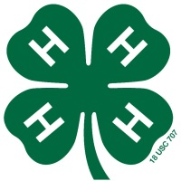
California 4-H Youth Development Program

Personal Development Report

Your picture
(optional)

County: _________________________________

Name of 4-H Club/Unit: _________________________________

Program Year: ____________ Total Years in 4-H: ___________

(Include years as a primary member)

Name: __________________________________

Birth Date: _________________ Gender:  Male  Female

Age on December 31: __________ Grade in School:__________
(of the program year listed above)

Address: ______________________________________________________________

City: __________________________________ State: ______ Zip: ____________

Email: ________________________________ Phone: (_____)___________________

A minimum completed club 4-H Record Book consists of the following items.
- Section 2: Personal Development Report
- Section 3: My 4-H Story
- Section 4: Projects - One project report form for every project completed

Club Meetings Attended This Year  During the current year, 80% attendance is  required for any achievement rank  Do not include project meetings. | Meetings Held | Meetings Attended | Hours Attended | Percent Attended

I have personally prepared this report and believe it to be correct.
Member’s Signature: | Date:
I have personally reviewed this report and believe it to be correct.
Parent/Guardian Signature: | Date:
4-H Community Club/Unit Leader’s Signature: | Date:

4-H Star Ranking

Record what you accomplished during the year. To qualify for any of the achievement rank awards, you must attend 80 percent of both the local club and the project meetings held during the year. To obtain any of the ranks, you must complete the asterisked (*) categories as a part of your total effort.
Bronze Star: Complete at least 5 of the 8 categories listed.
Silver Star: Complete at least 6 of the 8 categories listed.
Gold Star: Complete at least 7 of the 8 categories listed.
Platinum Star: Complete at least 7 of the 8 categories listed.
Star Ranks are designed to encourage members to participate in a wide variety of activities over a number of years. The bronze, silver, gold, and platinum stars build on past achievements.

Categories of Participation  Transfer credits from previous years to the column headed “Total From Past Years.” | Total Past Years | Total This  Year | Total All Years | Number of Different Categories Required
 |  |  |  | Bronze  5 Required | Silver  6 Required | Gold  7 Required | Platinum  7 Required
- 4-H Projects Completed |  |  |  | 2* | 4* | 8* | 12*
- 4-H Project Skill Activities |  |  |  | 4 | 8 | 15 | 20
- 4-H Events Attended |  |  |  | 12 | 25 | 40 | 60
- Leadership Development |  |  |  | 10 | 20 | 30* | 40*
Junior or Teen Leader |  |  |  | (0) | (0) | (2*) | (4*)
- Citizenship &  Community Service |  |  |  | 10 | 20* | 30* | 40*
- Communication Skills |  |  |  | 12* | 24* | 36* | 48*
4-H Presentations |  |  |  | (4*) | (7*) | (10*) | (15*)
- Honors and Recognition |  |  |  | 5 | 10 | 15 | 20
- Lifestyle Activities |  |  |  | 10 | 20 | 30 | 40
* Required for Star Rank
Numbers contained within parenthesis are included in the total category number (not an extra requirement).

Star Rank
4-H Member must be currently enrolled in the 4-H Youth Development Program.

Present Rank: [] None [] Bronze [] Silver [] Gold [] Platinum

Rank Applying for: [] None [] Bronze [] Silver [] Gold [] Platinum

[] Approved [] Not Approved __________________________
4-H Club/Unit Leader's Signature Date
Personal Development Report: Participation

1. 4-H Projects Completed This Year
Star Requirements: Bronze 2, Silver 4, Gold 8, Platinum 12
Total Past Years:_________ Total This Year: _________ Total All Years:________
During the current year, 80% average attendance across all projects is  required for any achievement rank. | Meetings  Held | Meetings Attended | Total Hours | Percent Attended
TOTALS
AVERAGE

Include your specific involvement (attended, competed, presented) and the level of participation:
I = Individual, L = Local Club/Unit/Project, C = County/Area/District,
M = Multi-county/Section, S = State, N = National/Multi-State, G = Global
You may add lines or add a page for each category, if needed.

2. 4-H Project Skill Activities
Star Requirements: Bronze 4, Silver 8, Gold 15, Platinum 20
Total Past Years:_________ Total This Year: _________ Total All Years:________
Date | Hours | Level | Activity Title & Brief Description | Location
Project Skill Activities Outside of 4-H (List up to two significant project skill activities)
 |  |  | Total Number:

Personal Development Report: Participation
Include your specific involvement (attended, competed, presented) and the level of participation:
I = Individual, L = Local Club/Unit/Project, C = County/Area/District,
M = Multi-county/Section, S = State, N = National/Multi-State, G = Global
You may add lines or add a page for each category, if needed.

3. 4-H Events Attended
Star Requirements: Bronze 12, Silver 25, Gold 40, Platinum 60
Total Past Years:_________ Total This Year: _________ Total All Years:________
Date | Hours | Level | Event Title | Location
 |  |  | Total Number:

4. 4-H Leadership Development
Star Requirements: Bronze 10, Silver 20, Gold 30, Platinum 40
Total Past Years:_________ Total This Year: _________ Total All Years:________
Required: Junior/Teen Leader Development Report
Total Past Years: ____ Total This Year: ____ Total All Years:____
Gold = 2 Platinum = 4 Met Requirement ___YES ___NO
Date | Hours | Level | Leadership Activity | Location
Leadership Development Outside of 4-H (List up to two significant leadership activities)
 |  |  | Total Number:

Personal Development Report: Participation
Include your specific involvement (attended, competed, presented, etc.) and the level of participation:
I = Individual, L = Local Club/Unit/Project, C = County/Area/District,
M = Multi-county/Section, S = State, N = National/Multi-State, G = Global
You may add lines or add a page for each category, if needed.

5. 4-H Citizenship & Community Service
Star Requirements: Bronze 10, Silver 20, Gold 30, Platinum 40
Total Past Years:_________ Total This Year: _________ Total All Years:________
Date | Hours | Level | Citizenship Activity | Location
Citizenship/Community Service Outside of 4-H (List up to two significant citizenship activities)
 |  |  | Total Number:

6. 4-H Communication Skills
Star Requirements: Bronze 12, Silver 24, Gold 36, Platinum 48
Total Past Years:_________ Total This Year: _________ Total All Years:________
Required: 4-H Presentations Total Past Years: ____ Total This Year: ____ Total All Years:____
Bronze = 4 Silver = 7 Gold = 10 Platinum = 15 Met Requirement ___YES ___NO
Date | Hours | Level | Communication Activity | Location
Communication Development Outside of 4-H (List up to two significant communication activities)
 |  |  | Total Number:
Personal Development Report: Participation
Include your specific involvement (attended, competed, presented, etc.) and the level of participation:
I = Individual, L = Local Club/Unit/Project, C = County/Area/District,
M = Multi-county/Section, S = State, N = National/Multi-State, G = Global
You may add lines or add a page for each category, if needed.

7. 4-H Honors/Recognition
Star Requirements: Bronze 5, Silver 10, Gold 15, Platinum 20
Total Past Years:_________ Total This Year: _________ Total All Years:________
Date | Hours | Level | Honor or Recognition | Location
Honors and Recognition Outside of 4-H (List up to two significant honors)
 |  |  | Total Number:

  - 8. Lifestyle Activities
Star Requirements: Bronze 10, Silver 20, Gold 30, Platinum 40
Total Past Years:_________ Total This Year: _________ Total All Years:________
Date | Hours | Level | Activity or Organization | Location
 |  |  | Total Number:

Section 3: My 4-H Story Instructions

The 4-H story is an opportunity for members to share experiences in 4-H. The story should be a record of all years in 4-H and emphasize the current year in 4-H. Use the page length recommendations outlined below and printed only on one side of the pages.
- Junior (or first year member): 1 – 2 pages
- Intermediate: 2 – 4 pages
- Senior: 3 – 6 pages
Do not exceed 6 pages.

The following may help in developing the story:
Pick a theme and build the story around that theme. Members experienced in writing essays may know to build the 4-H story so that it flows naturally. Members new to writing essays can use the following questions to help think about what to say.

Part 1 - About You.
- How old are you and when did you join 4-H?
- Why did you join 4-H?
- What are your sparks: interests, passions, and skills?
- What are your plans for the future?
Part 2 – 4-H Projects and Activities.
- What projects have you taken? How successful were they?
- What goals did you set and which ones did you reach?
- What would you do differently if you were to try it again?
- What skills have you learned in the program?
- Have your projects grown in size and scope?
- How have you arranged for financing, if needed?
- Were any adults or other 4-H members especially helpful to you? How?
Part 3 – Leadership and Citizenship.
- What do leadership and citizenship mean to you?
- Has 4-H helped you become a better leader and citizen? How? What types of citizenship or leadership projects have you been involved in?
- How have you contributed to 4-H, your community, and your school?
- Describe the most important offices you have held and the committee assignments you have accepted.
- What have you learned from working with other 4-H'ers as a junior or teen leader?
Part 4 – 4-H’s Impact on You.
- What kinds of relationships have you had with your 4-H leaders?
- How has your 4-H participation changed how you feel about yourself?
- How has your participation influenced your school and career goals?
- What has being a 4-H member meant to you?

Section 4: Annual Project Report (APR) Instructions

Projects provide the basic framework for 4-H teaching and learning experiences. Projects provide cooperative learning opportunities, a well-documented context for effective learning. Each year 4-H members will participate in at least one project. A project is:
- Planned work in an area that is of interest to the 4-H member.
- Aimed at planned objectives that the 4-H member can attain and measure.
- Guided by a 4-H adult volunteer.
- Summarized by some form of record keeping.

A minimum of six hours of project instruction is required to complete a project. The county 4-H staff must approve all county or unit requirements for project completion.

Completing this Section

This section is used by the 4-H member to document their specific project work. Place items in the following order for each separate project:
- An Annual Project Report form for every project the member has completed.
- Expression page
- Junior/Teen Leadership Development Report

Section 4-A: Annual Project Report Form

In the Learning Experiences box, explain what the 4-H member did, learned, and life skills gained in the project during the year. This includes activities that took place during project meetings, shows, and events. The 4-H member may record items raised, grown or improved, honors and awards, citizenship and leadership activities, and profit/loss related to the project on the second page of the form. The 4-H member may decide to document simulated "money" from the project in the profit/loss box if it is relevant to the project.

Each Annual Project Report form completed and signed by the Project Leader counts as a separate project on the PDR (under #1 Projects Completed).

Expression Page (Not to be confused with the Collection of Work)

Include one Expression page for each Annual Project Report. Page must be one side of an 8 ½” x 11” piece of paper. The 4-H member may draw, write, use graphic design elements, etc.

Tips for Expression Pages:
- sparks
- be creative
- teach the reader something that you learned which was interesting to you
- design is age appropriate

Note:

The Expression Pages are not to be used to expand the Collection of Work.

Photos should demonstrate something that you learned which was interesting to you.


California 4-H Youth Development Program

Annual Project Report
Submit one form per project.
Members may add additional pages if needed for a maximum of four pages per project.

Name |  | Program Year
Project |  | Years in Project
 | Number of project meetings held |  |  | % Attended
 | Number of project meetings attended |  |  | % Attended

LEARNING EXPERIENCES
Explain what you did, what you learned, and the
skills you gained in the project.
Include the level of participation: I = Individual, L = Local Club/Unit/Project, C = County/Area/District,
M = Multi-county/Section, S = State, N = National/Multi-State, G = Global
Date | Level | Hours | Activity Title | Location | Learning Experience

Project Report Form (Continued)

Number | List things made, raised,  grown, or improved. | List honors or awards earned.

List citizenship activities | List leadership development activities

Expenses and Income/Value
Summarize, totaling all expenses such as: ingredients, feed, vet supplies/visits, materials, exhibitor's fees, and all income such as: value of finished products, animals sold, exhibit premiums, etc.
Item | Number | Expense | Income  or Value
 |  | $ | $
 |  | $ | $
 |  | $ | $
 |  | $ | $
 |  | $ | $
 | Totals | $ | $
Total Profit or Loss |  | $

If another member was thinking about taking this project next year, what would you tell him/her about what can be learned in this project?

I have personally prepared this report and believe it to be correct.
4-H Member’s Signature: | Date:
I have personally reviewed this report and believe it to be correct.
4-H Project Leader’s Signature: | Date:

Section 4-B: Junior and Teen
Leadership Development Report (JTLDR) Instructions

The 4-H Junior and Teen Leadership experience is designed to provide members with the opportunity to learn about the qualities and competencies needed to be a leader. Leadership is not doing things for the group, it is helping the group decide what needs to be done and how. Junior Leaders provide assistance while Teen Leaders assume more challenging leadership roles. Junior and Teen Leaders may assist with specific projects or with other 4-H activities or events. A 4-H member may be a Junior or Teen Leader for one or more projects during the year. The major duties of a Junior or Teen Leader are (varies by age, experience, and other factors):
- Work collaboratively with the adult leader to set goals, develop lesson plans, teach skills, and evaluate the activity.
- Coordinate logistical details such as meeting times, locations, materials and supplies, and expenses with the adult leader.
- Communicate with the adult leader and members about group expectations, responsibilities, and expected outcomes.

At the beginning of the year, the 4-H member and the adult leader should meet to discuss the project and define each of their roles. The 4-H member should complete the pre-project part of the form. At the end of the year, the 4-H member must complete the post-project part of the form and include the entire form in his/her Record Book to receive credit.

Junior Leaders (Intermediate Members): To become a junior leader, youth must be in grades 6-8, or if home-schooled, must be at least 11 and no more than 13 years old as of December 31 of the program year.

Teen Leaders (Senior Members): To become a teen leader, youth must be in the ninth grade or above, or if home-schooled, must be at least 14 years old as of December 31 of the program year.

Completing the Junior and Teen Leadership Development Report

Each Junior or Teen Leadership Development Report form completed and signed by the Project Leader (or team advisor) counts as a separate credit on the PDR (under #4 Leadership Development). This form may also be completed for the activities specified here: county All Stars; club officers; 4-H State Ambassadors; leadership development project; domestic or international exchange project; or camp counselor.

Note: There may be cases where the 4-H member is a Junior or Teen Leader for a project but does not actively participate in the project. In this case, the 4-H member will fill out the Junior and Teen Leadership Development Report and not the Annual Project Report. A credit is given in the PDR for a Junior/Teen Leader and not for a project completed.

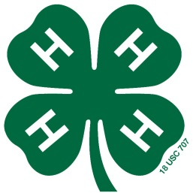
California 4-H Youth Development Program

Junior and Teen Leadership Development Report
Submit one form per project or activity.
Add no more than 2 additional pages, if needed, to answer all of the questions.

Name |  |  |  |  |  | Program Year
Project |  |  |  |  |  | Years in Project
Club |  |  |  |  |  | Number of Members
Project Leader’s Name
[] | Leadership Development Project |  |  | [] | Junior Leader |  | [] |  | Teen Leader
[] | All Star Ambassador |  |  | [] | Club Officer |  | [] |  | Exchange
[] | State Ambassador |  |  | [] | Camp Counselor

Complete questions one through five before the project or activity begins:

1. Briefly describe the overall project or activity. What is the project or activity and why is it important?

Junior and Teen Leadership Development Report (Continued)

2. Goal Selection

I. Record the goals you have for this project or activity. Think of each goal as a destination.

II. Record goals for your leadership development. At the end of the project or activity, which of the 6 Cs (confidence, competence, character, caring, connection, contribution) do you plan to increase?

3. Pursue Strategies

What are the steps you will take to reach your goals? Include by when, by whom, and the specific actions.

Junior and Teen Leadership Development Report (Continued)

4. Shift Gears

What are some things that may get in the way of achieving your goals? What can you do to overcome those challenges or obstacles?

5. What advice would you give other members if they are struggling with a challenging task?

Approval of Plans
I have personally prepared this report and believe it to be correct.
4-H Member’s Signature: | Date:
I have personally reviewed this report and believe it to be correct.
4-H Project Leader’s Signature: | Date:

Junior and Teen Leadership Development Report (Continued)

Complete questions six through eight after the project or activity concludes:

6. What were your roles and responsibilities in this project or activity? Did you identify a spark, passion, or interest? What did you do and learn?

7. What specific leadership skills did you develop? Which of the 6 Cs (confidence, competence, character, caring, connection, contribution) did this project help you to grow? In what way?

Junior and Teen Leadership Development Report (Continued)

8. How will you use the skills you learned in future 4-H and other activities?

9. For the Project Leader: Please provide feedback and comments on the 4-H member’s leadership role.

Approval of Report
I have personally prepared this report and believe it to be correct.
Member’s Signature: | Date:
I have personally reviewed this report and believe it to be correct.
4-H Project Leader’s Signature: | Date:

Section 5: Collection of 4-H Work

The Collection of 4-H Work acts as a portfolio to support the other sections of the
4-H Record Book. A collection of 4-H work allows the 4-H member to demonstrate some of their activities during the year. The Collection of 4-H Work is limited to 11 pages and follows the standard formatting and paper guidelines except as noted below.

Note: The Online Record Book will allow members to upload additional items; however, when the member compiles their hardcopy Record Book at the end of the year, he/she will need to select items so the Collection of 4-H Work does not exceed 11 pages.

The following items may be included. Items may be compiled in any order and must represent the current 4-H year.

Newspaper or Newsletter Articles 2 pages maximum
Limited to two pages, single-sided.
Newspaper or newsletter articles must be written by the 4-H member or about the 4-H member. Articles may not be shingled. They must be firmly attached to the page. Digital copies or printouts from on-line sources are acceptable. List source and date.

Flyers or Brochures 2 maximum
Limited to two brochures or flyers, single or double sided. Flyers or brochures must feature the member or must have been created by the member. Brochure may be attached to a standard sheet of paper or hole-punched and inserted.

Letters or Certificates 2 maximum
Limited to two letters and/or certificates, single-sided.
Letters may either be written by the 4-H member or about the 4-H member. Certificates must have been presented to the member in the current 4-H year.

Photographs 5 pages maximum
Limited to five pages, single-sided.
Photographs should show project work, leadership, and citizenship activities. Captions for each photo should explain what is taking place in the photograph and indicating when and where the photograph was taken. Space used for captions counts as part of the five pages. Pictures may not be shingled. They must be firmly attached to the page (no “flip-ups”). Digital or computerized photos are acceptable. You may use photo quality paper.

Total: 11 pages/items maximum

Section 6: Previous Years’ Records

The following instructions are for State Competition: Record Book pages from all previous years in 4-H must be removed and replaced with a summary of your previous involvement in 4-H (the 4-H member may include all involvement as a 4-H member, including primary). These pages must be placed at the back of the 4-H Record Book and must conform to the standard formatting and page guidelines. This section is limited to three pages. Many 4-H members use a bulleted list or table to summarize their previous experience, but any format is acceptable.

Include in your description for each of the three pages:
- dates you were involved
- role you played in the activity
- size and scope of your project/activity
- accomplishments, alone or working with others
- designate level of participation with the appropriate letter:

I = Individual: independent, individual activity, not as part of a group.

L = Local club, unit, project, club/project committee

C = County, area/district, multi-club

M = Multi-county, section, or region

S = State

N = National, multi-state

G = Global, international, crossing U.S. boundaries

Page Maximum: Three (3) pages, one-sided, total for all three categories – One page to summarize projects, one page to summarize leadership development and one page to summarize citizenship development. For Parts A, B and C: members are limited to one side of one page and MAY NOT use both sides of the page.

Part A: Project Summary

On one sheet of paper, describe all of your 4-H project work and project learning experiences throughout your years in 4-H. Show examples of how your project meets the following:
- Participation in 4-H learning experiences such as demonstrations, talks, exhibits, judging events, field trips, tours, workshops, conferences and camps attended, and activities where you taught others.
- Knowledge and skills gained from working on the 4-H projects or activities. Review your total time in this program; consider goals you have had, and summarize the knowledge and skills gained.
- Size and scope of your 4-H projects or activities. Size means anything that can be expressed in quantity. Select examples that show your growth through 4-H participation. Scope refers to range of operation and growth, over time. Use numbers carefully to show size and depth of growth within this program.

Part B: Leadership Summary

On one sheet of paper, describe all of your 4-H leadership experiences and other significant leadership experiences you have had outside of 4-H, in school or community organizations throughout your total years in 4-H. Show examples of how you have:
- Collaborated with others and served as a role model for other members
- Identified and understood roles, attitudes, and tasks necessary for effective leadership
- Worked in a youth-adult partnership
- Worked as a member of a team at club, county, regional, state and national levels
- Assumed responsibility for program planning and implementation
- Served as a Junior or Teen Leader for 4-H projects

Part C: Citizenship Summary

On one sheet of paper, describe 4-H citizenship and service-learning experiences you have had in

4-H and community organizations throughout your total years in 4-H. Citizenship is defined as acting with informed concern for self and others as an individual or group action. Service-Learning has been defined as a type of experiential education (hands-on) that involves young people in both community service and education. Show examples of how you have:
- Been involved in the planning and action on specific community improvement projects
- Collaborated with other community resources to identify and develop programs
- Demonstrated social responsibility
- How your community has benefited or been improved
- How you have worked cooperatively with other community programs or agencies
- What you have learned about the global community

Tips:

Make it easy to read
- If you use a table or chart, list in reverse chronological order
- This is a summary, edit the list to include those things that demonstrated significant growth and learning
- For examples and ideas of layout, see some past winning books on the Website: www.ca4h.org

"Creativity takes courage." - Henri Matisse

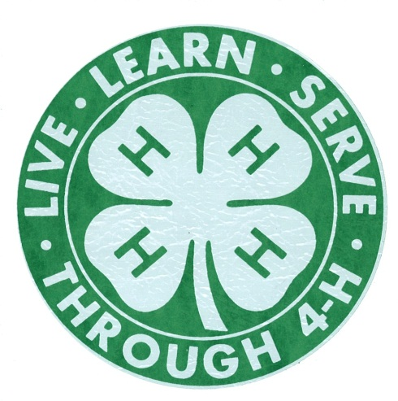

4-H Record Book Resources

Primary Record Book Webpage
http://www.ca4h.org/Resources/Members/RecordBook/

Online Record Book
http://www.ca4h.org/orb/

Download 4-H Record Book forms
http://www.ca4h.org/Resources/Members/RecordBook/RBResources/

Competition information
http://www.ca4h.org/Resources/Members/RecordBook/RBCompetition

Join the 4-H Record Book support group
http://groups.yahoo.com/group/ca4hrb/

Questions and comments may be directed to:
California State 4-H Office
University of California, Davis
One Shields Avenue, Davis, CA 95616-8575
530-754-8518 fourhstateofc@ucdavis.edu

